

Project Title: Improving Database System for the Hospital
Group Members Names
Jeel Patel: 100931324
Kartik Pandit: 100935721
Harshil Rao: 100935323
Submission Date: 27-11-2024

Contents
Introduction: 3
Draft As-Is Contextual: 4
Level-1 Data Flow Diagram: 5
Functional Requirements 6
Non-Functional Requirements 8
Draft 3NF Normalized Relational Schema in “Shorthand”: 10
Draft Entity Relationship Diagram: 11

Introduction:
Lake Ridge Community Hospital (LRCH) is facing some challenges in their current data and management system. Moreover, that new operation systems in database faces delays in some necessary duties. Furthermore, main goal of that project is to develop a real- time information database system to solve those problems. The new system will ensure correct data-processing and support static decision-making for more effective healthcare services.

Mission statement:
Our aim is to provide good design and implement a real-time information for Lake Ridge community Hospital. This system will significantly enhance patient safety up to date for operational management. Ultimately, that solution will enhance healthcare system, operational efficiency and promotes patient outcomes and satisfaction.

Draft As-Is Contextual:
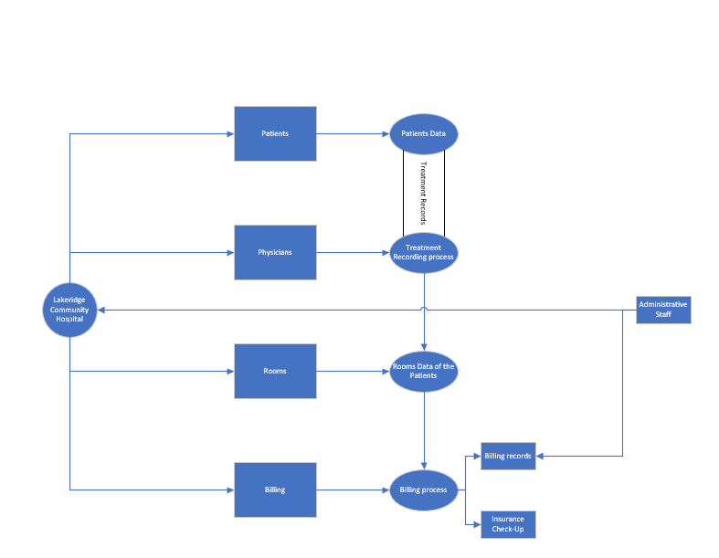

Level-1 Data Flow Diagram:

Functional Requirements
- Room Management
  - The system should identify and display occupied and available rooms.
  - It should display room types (e.g., ICU, private room, etc.).
  - It should save and update room information as patients are admitted and discharged.

- Patient Management
  - The system should allow for storing patient details.
  - It should provide functionality to book and manage patient appointments.
  - It should handle patient admission processes, including setting up insurance and verifying coverage.
  - The system should maintain patient records, track diagnoses, treatments, and follow-up requirements.

- Billing and Financial Management
  - The system should process insurance claims by connecting with insurance providers.
  - It should generate financial summaries for administrative purposes.
  - The billing department should be able to create and send patient invoices.
  - It should validate and process payments from patients.

- Medical Examination and Treatment
  - The system should support physicians in recording consultations, evaluations, diagnoses, and treatment plans.
  - It should facilitate follow-up bookings for ongoing treatment and track patient progress.

- Discharge Process
  - The system should manage patient discharge and update records accordingly.
  - It should notify other departments of patient discharge to free up resources.

Non-Functional Requirements
- Reliability
  - The system should be reliable, with minimal downtime, to support 24/7 hospital operations.
  - Patient and billing data should be accurately stored and retrieved without loss or corruption.

- Scalability
  - The system should support an increasing number of patients, records, and appointments as the hospital grows.

- Usability
  - The interface should be intuitive for healthcare providers, billing staff, and administrators, reducing training time and errors.
  - Different user roles (e.g., physician, billing, admin) should have customized interfaces and access permissions.

- Data Security and Privacy
- Patient data and financial information must be securely stored and comply with healthcare regulations (e.g., HIPAA in the US).
  - Access to sensitive information should be restricted based on user roles.

- Performance
  - The system should handle multiple users and concurrent processes without noticeable delays, especially during high-demand periods.

- Maintainability
  - The system should be easy to update or modify as new healthcare regulations or billing requirements arise.
  - Logs should be maintained for system errors and access records to aid troubleshooting and audits.

- Integration with External Systems
  - The system should integrate smoothly with external insurance providers for claim processing and verification.
  - It should allow for the export of financial summaries and reports for auditing purposes.

Draft 3NF Normalized Relational Schema in “Shorthand”:
Patients Table
- Attributes: PatientID, LastName, FirstName, DOB, Address, Gender, InsuranceID
Physicians Table
- Attributes: PhysicianID, FirstName, LastName, Specialization, Email
Appointments Table
- Attributes: AppointmentID, PatientID, PhysicianID, Date, Status, ReasonForVisit, Time
Admissions Table
- Attributes: AdmissionID, PatientID, RoomID, AdmissionDate, InsuranceVerified, TreatmentPlan
Rooms Table
- Attributes: RoomID, RoomType, Capacity, Occupancy, RoomsAvailable
PatientRecords Table
- Attributes: RecordID, PatientID, VisitDate, Treatment, FollowUpDate
InsuranceClaims Table
- Attributes: InsuranceClaimID, PatientID, InsuranceID, ClaimAmount, ClaimDate, ApprovalDate
Billing Table
- Attributes: BillingID, PatientID, TotalAmount, InvoiceDate, DueDate, InsuranceClaimID, PaymentStatus
Bed Table
- Attributes: BedID, RoomID,bed_number, patientID
InsuranceID
- Attributes: InsuranceID , providename , province, city , postalcode, phone number , email

Draft Entity Relationship Diagram:

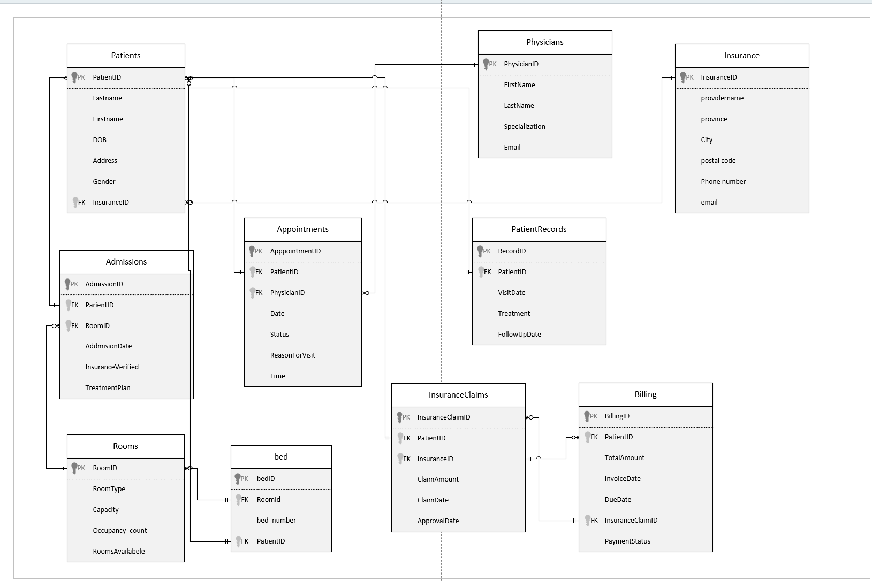

Data Dictionary

TABLE: INSURANCE
ATTRIBUTE NAME | CONTENTS | TYPE | FORMAT | RANGE | REQUIRED | PK OR FK | FK REFERENCED TABLE
InsuranceID | Insurance provider ID | INT | 9 | 1–999999 | Y | PK
ProviderName | Insurance provider name | VARCHAR (100) | Xxxxxxxxxxxxxxx | - | Y
Province | Province of insurer | VARCHAR (50) | Xxxxxxxxxxxxxxx | - | Y
City | City of insurer | VARCHAR (50) | Xxxxxxxxxxxxxxx | - | Y
PostalCode | Postal code | VARCHAR (10) | XXX XXX | - | Y
PhoneNumber | Phone number | VARCHAR (15) | 999-999-9999 | - | Y
Email | Email ID | VARCHAR (100) |  | - | Y

TABLE: PATIENTS
ATTRIBUTE NAME | CONTENTS | TYPE | FORMAT | RANGE | REQUIRED | PK OR FK | FK REFERENCED TABLE
PatientID | Unique ID for patient | INT | 10 | 1–999999 | Y | PK
LastName | Patient's last name | VARCHAR (50) | Xxxxxxxxxxxxxxx | - | Y
FirstName | Patient's first name | VARCHAR (50) | Xxxxxxxxxxxxxxx | - | Y
DOB | Patient's date of birth | DATE | dd-mm-yyyy | - | Y
Address | Patient address | VARCHAR (100) | XXXXX, XXXXXX | - | Y
Gender | Gender | CHAR (1) | M/F/O | - | Y
InsuranceID | Insurance used by patient | INT | 9999 | 1–999999 | N | FK | INSURANCE

TABLE: PHYSICIANS
ATTRIBUTE NAME | CONTENTS | TYPE | FORMAT | RANGE | REQUIRED | PK OR FK | FK REFERENCED TABLE
PhysicianID | Unique ID for physician | INT | 10 | 1–999999 | Y | PK
FirstName | First name | VARCHAR (50) | Xxxxxxxxxxxxxxx | - | Y
LastName | Last name | VARCHAR (50) | Xxxxxxxxxxxxxxx | - | Y
Specialization | Specialty | VARCHAR (50) | Xxxxxxxxxxxxxxx | - | Y
Email | Contact email | VARCHAR (100) |  | - | Y

TABLE: ROOMS
ATTRIBUTE NAME | CONTENTS | TYPE | FORMAT | RANGE | REQUIRED | PK OR FK | FK REFERENCED TABLE
RoomID | Unique ID for room | INT | 10 | 1–999999 | Y | PK
RoomType | Room type | VARCHAR (20) | Xxxxxxxxxxxxxxx | ICU/Private/etc. | Y
Capacity | Room capacity | INT | ## | 1–10 | Y
Occupancy | Current occupancy count | INT | ## | 0–10 | Y
RoomsAvailable | Available rooms of type | INT | ## | 0–10 | Y

TABLE: APPOINTMENTS
ATTRIBUTE NAME | CONTENTS | TYPE | FORMAT | RANGE | REQUIRED | PK OR FK | FK REFERENCED TABLE
AppointmentID | Unique ID for appointment | INT | 10 | 1–999999 | Y | PK
PatientID | Linked patient | INT | 10 | 1–999999 | Y | FK | PATIENTS
PhysicianID | Linked physician | INT | 10 | 1–999999 | Y | FK | PHYSICIANS
Date | Appointment date | DATE | dd-mm-yyyy | - | Y
Time | Appointment time | TIME | hh:mm:ss | - | Y
Status | Appointment status | VARCHAR (20) | XXXXXXXX | Scheduled/Completed/... | Y
ReasonForVisit | Reason for visit | VARCHAR (200) | Xxxxxxxxxxxxxxx | - | N

TABLE: ADMISSIONS
ATTRIBUTE NAME | CONTENTS | TYPE | FORMAT | RANGE | REQUIRED | PK OR FK | FK REFERENCED TABLE
AdmissionID | Unique admission ID | INT | 10 | 1–999999 | Y | PK
PatientID | Linked patient | INT | 10 | 1–999999 | Y | FK | PATIENTS
RoomID | Assigned room | INT | 10 | 1–999999 | Y | FK | ROOMS
AdmissionDate | Date of admission | DATE | dd-mm-yyyy | - | Y
InsuranceVerified | Insurance verification status | BOOLEAN | true/false | 0/1 | Y
TreatmentPlan | Detailed treatment plan | VARCHAR (500) | Xxxxxxxxxxxxxxx | - | N

TABLE: PATIENTRECORDS
ATTRIBUTE NAME | CONTENTS | TYPE | FORMAT | RANGE | REQUIRED | PK OR FK | FK REFERENCED TABLE
RecordID | Unique record ID | INT | 10 | 1–999999 | Y | PK
PatientID | Linked patient | INT | 10 | 1–999999 | Y | FK | PATIENTS
VisitDate | Date of visit | DATE | dd-mm-yyyy | - | Y
Treatment | Treatment description | VARCHAR (500) | Xxxxxxxxxxxxxxx | - | Y
FollowUpDate | Follow-up date | DATE | dd-mm-yyyy | - | N

TABLE: INSURANCECLAIMS
ATTRIBUTE NAME | CONTENTS | TYPE | FORMAT | RANGE | REQUIRED | PK OR FK | FK REFERENCED TABLE
InsuranceClaimID | Unique claim ID | INT | 10 | 1–999999 | Y | PK
PatientID | Linked patient | INT | 10 | 1–999999 | Y | FK | PATIENTS
InsuranceID | Linked insurance provider | INT | 10 | 1–999999 | Y | FK | INSURANCE
ClaimAmount | Amount claimed | DECIMAL (10,2) | 999999.99 | 0–999999.99 | Y
ClaimDate | Date claim filed | DATE | dd-mm-yyyy | - | Y
ApprovalDate | Date claim approved | DATE | dd-mm-yyyy | - | N

TABLE: BILLING
ATTRIBUTE NAME | CONTENTS | TYPE | FORMAT | RANGE | REQUIRED | PK OR FK | FK REFERENCED TABLE
BillingID | Unique billing ID | INT | 10 | 1–999999 | Y | PK
PatientID | Linked patient | INT | 10 | 1–999999 | Y | FK | PATIENTS
TotalAmount | Total invoice amount | DECIMAL (10,2) | 999999.99 | 0–999999.99 | Y
InvoiceDate | Invoice date | DATE | dd-mm-yyyy | - | Y
DueDate | Payment due date | DATE | dd-mm-yyyy | - | Y
InsuranceClaimID | Linked insurance claim | INT | 10 | 1–999999 | N | FK | INSURANCECLAIMS
PaymentStatus | Payment status | VARCHAR (20) | XXXXXXXXXX | Pending/Paid/... | Y

TABLE: BED
ATTRIBUTE NAME | CONTENTS | TYPE | FORMAT | RANGE | REQUIRED | PK OR FK | FK REFERENCED TABLE
BedID | Unique bed ID | INT | 10 | 1–999999 | Y | PK
RoomID | Linked room | INT | 10 | 1–999999 | Y | FK | ROOMS
BedNumber | Bed number within room | INT | 99 | 1–99 | Y
PatientID | Currently assigned patient | INT | 10 | 1–999999 | N | FK | PATIENTS

Create Statements:
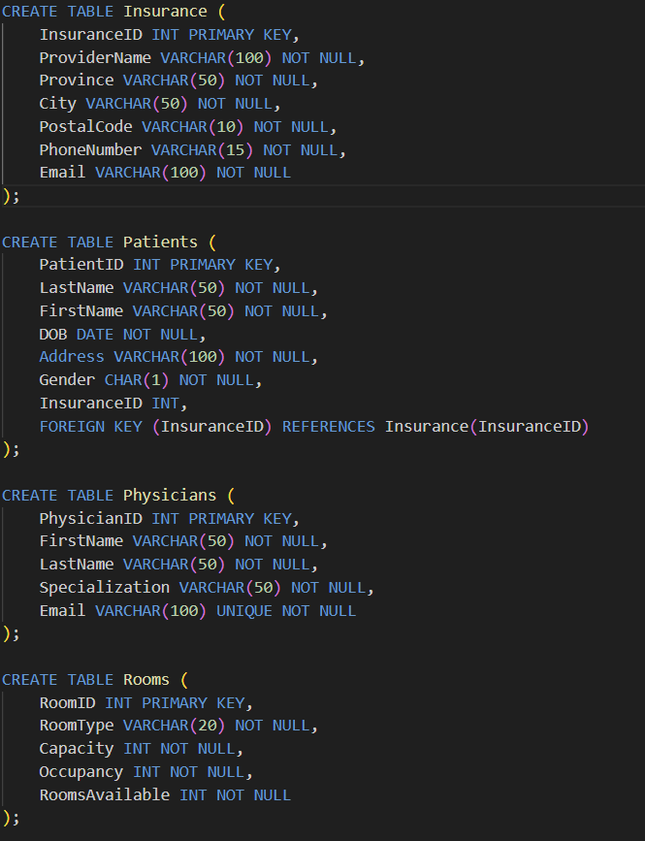

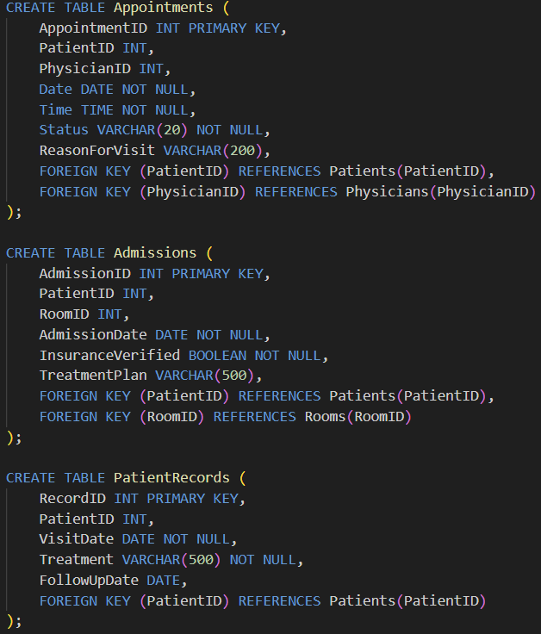

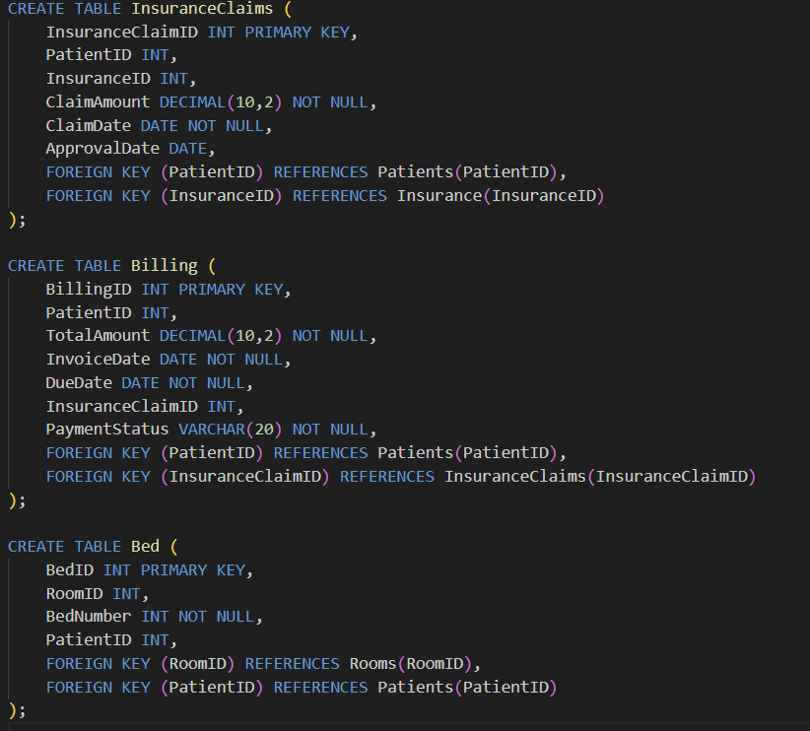

Insert Statements:
